Pre-CAS Interview Process Guide

This document provides a guide to conducting pre-CAS interviews and the processes implemented when conducting them. It is ordered in the stages by which you would be completing the tasks when completing pre-CAS interviews.

## Contents

1. Check Calendar and Emails 2

2. Run Export List report for ‘Open’ Appointments 4

3. Check student information and prepare interview template 6

4. Contacting the student 10

5. Post-interview 16

6. Emailing the student 18

7. Update Interview Outcomes spreadsheet 21

## Checking Calendar and Emails

The first step of the process is to check your daily schedule on TimeTap. To view your schedule, login to your TimeTap account and go to the ‘Appointments’ page, which will take you to your calendar (for more information on using TimeTap, please refer to the [TimeTap Guide](https://my.studygroup.com/teams/Visa%20Compliance%20UK%20and%20EU/_layouts/15/WopiFrame.aspx?sourcedoc=/teams/Visa%20Compliance%20UK%20and%20EU/Policy%20Library/Visa%20Team%20ONLY/8.%20Pre-CAS%20Interviews/5.%20TimeTap/TimeTap%20Guide.docx&action=default)).

Once on the calendar page, you can view the appointments you have scheduled for the day (please see appointments scheduled for Wednesday 22 April in the image below).

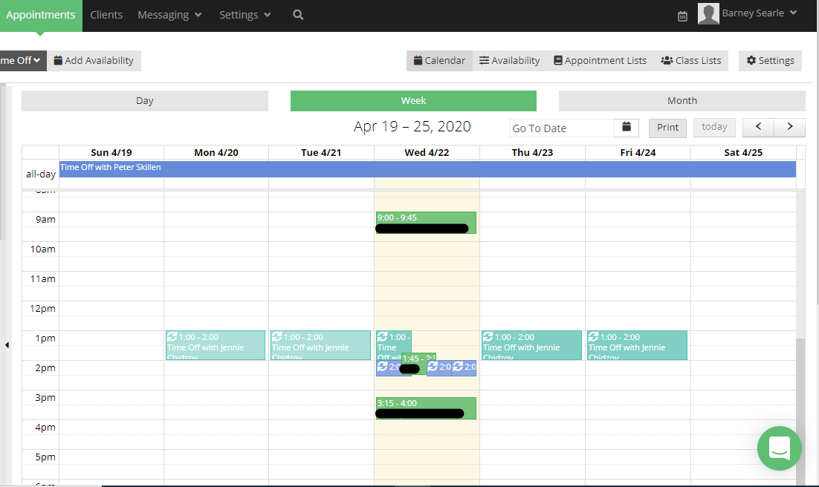

You should check your emails for notifications or reminders you have received regarding appointments that have been booked. You may have received reminders for a scheduled appointment, or an email to notify you of an appointment that has been cancelled (see below).

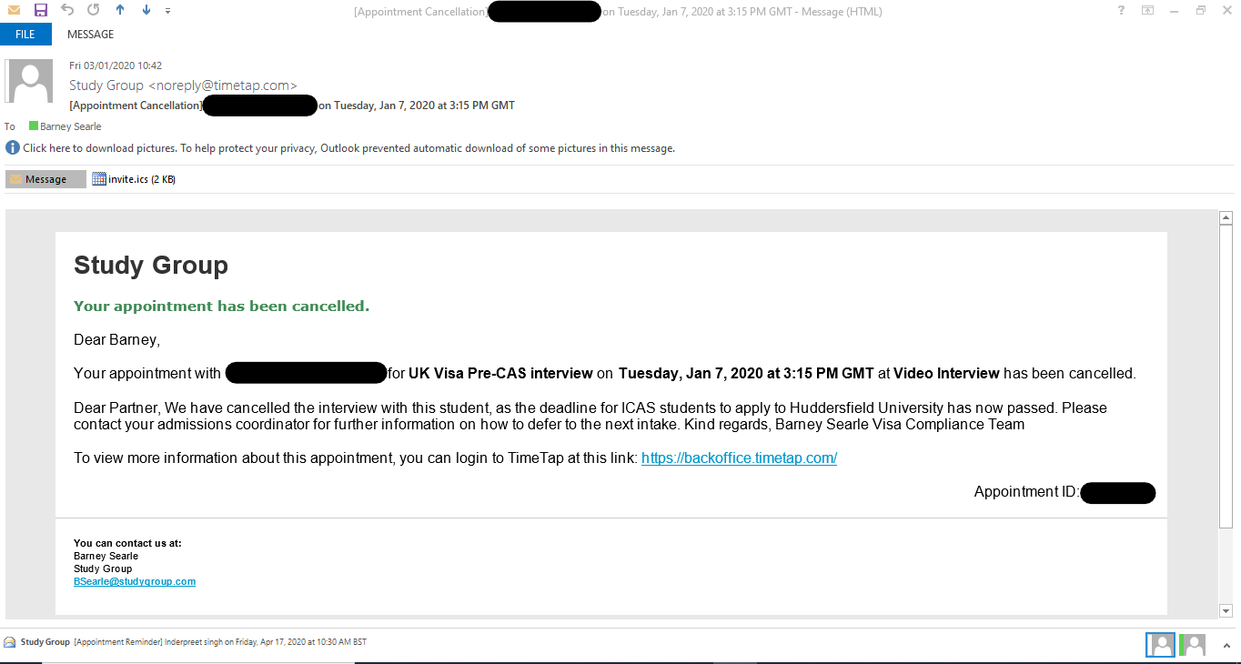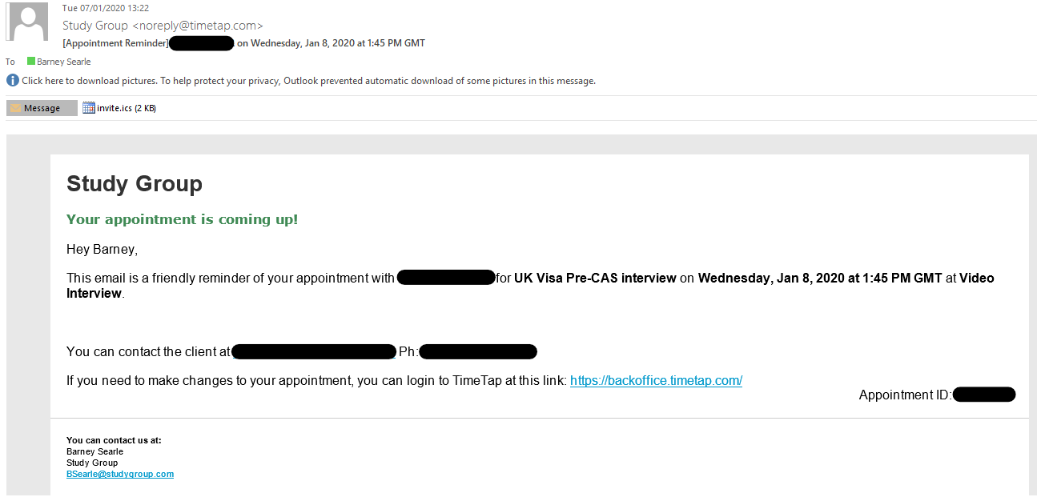

## Run Export List report for ‘Open’ Appointments

One person will run an ‘Export List’ Appointment for all the ‘Open’ Appointments scheduled for each day. Doing this at the start of each working day will help keep a record of all the appointments scheduled, and these appointments can then be added to a large spreadsheet to maintain a record of all completed appointments and interview outcomes.

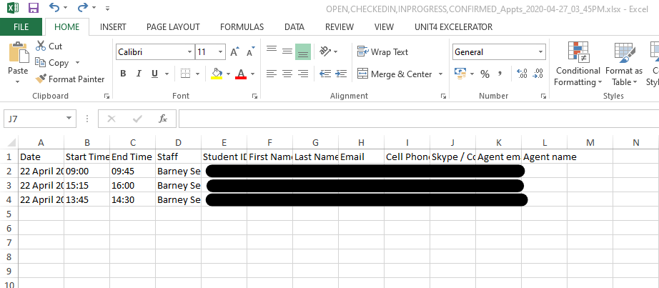Full instructions on how to run this report on TimeTap are available in the ‘Running Reports’ Section of the [TimeTap Guide](https://my.studygroup.com/teams/Visa%20Compliance%20UK%20and%20EU/_layouts/15/WopiFrame.aspx?sourcedoc=/teams/Visa%20Compliance%20UK%20and%20EU/Policy%20Library/Visa%20Team%20ONLY/8.%20Pre-CAS%20Interviews/5.%20TimeTap/TimeTap%20Guide.docx&action=default). The report should produce a spreadsheet that looks similar to the one in the image below).

Creating this report will then allow you to add details about each appointment to the [‘Interview Outcomes’ spreadsheet](https://my.studygroup.com/teams/Visa%20Compliance%20UK%20and%20EU/_layouts/15/WopiFrame.aspx?sourcedoc=/teams/Visa%20Compliance%20UK%20and%20EU/Policy%20Library/Visa%20Team%20ONLY/8.%20Pre-CAS%20Interviews/Master%20Pre-CAS%20Interview%20Outcomes%20from%20Q3%20(July%202020%20onwards)%20.xlsx&action=default) – this spreadsheet keeps a record of the details of each appointment, the student, and the outcome of the interview. This is beneficial for keeping a record of interview outcomes to conduct statistical tests or identify trends in outcomes.

Before adding rows from the report onto the interview outcomes spreadsheet, the report spreadsheet should be amended to ensure it is compatible with the interview outcomes sheet:

* The ‘Student ID’ column should be moved from column J to in between the ‘Staff’ column and ‘First Name’ column.
* 9 new columns should then be created between the ‘Student ID’ and ‘First Name’ columns.

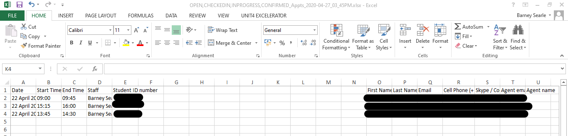Once you have done all of these, the report spreadsheet should have 21 columns (A-U) and should look like the spreadsheet below:

You then need to copy and paste these rows of data onto the bottom of the [Interview Outcomes spreadsheet](https://my.studygroup.com/teams/Visa%20Compliance%20UK%20and%20EU/_layouts/15/WopiFrame.aspx?sourcedoc=/teams/Visa%20Compliance%20UK%20and%20EU/Policy%20Library/Visa%20Team%20ONLY/8.%20Pre-CAS%20Interviews/Master%20Pre-CAS%20Interview%20Outcomes%20from%20Q3%20(July%202020%20onwards)%20.xlsx&action=default).

You should repeat this process every day (when interviews are booked) to ensure any interviews are included in the report and recorded in the Interview Outcomes spreadsheet. You will then be able to use these interview outcomes to run statistical tests, create graphs/charts and identify trends.

## Check student information and prepare interview templates

Before any appointments take place, you need to check the student’s course details and status, and add these to the interview template used for recording students’ interview answers. There is an interview [template for first interviews](https://my.studygroup.com/teams/Visa%20Compliance%20UK%20and%20EU/_layouts/15/WopiFrame2.aspx?sourcedoc=/teams/Visa%20Compliance%20UK%20and%20EU/Policy%20Library/Visa%20Team%20ONLY/8.%20Pre-CAS%20Interviews/1.%20Interview%20Templates/Updated%20First%20Interview%20Pre-CAS%20Interview%20template%20Jan%202020.docx&action=default) and a [template for second interviews](https://my.studygroup.com/teams/Visa%20Compliance%20UK%20and%20EU/_layouts/15/WopiFrame.aspx?sourcedoc=/teams/Visa%20Compliance%20UK%20and%20EU/Policy%20Library/Visa%20Team%20ONLY/8.%20Pre-CAS%20Interviews/1.%20Interview%20Templates/Second%20Interview%20-%20Pre-CAS%20Interview%20Template%20(Feb%202020).docx&action=default) – the templates have the same questions, but with slightly amended wording and ordered differently (this ensures the student cannot just memorise answers in the order from the first interview in preparation for the second interview).

The first page of the interview template is shown below – these sections need to be filled in before the student is contacted. At the beginning of the interview, the student needs to be asked these details to confirm they are correct, so these details need to be inputted before the interview starts.

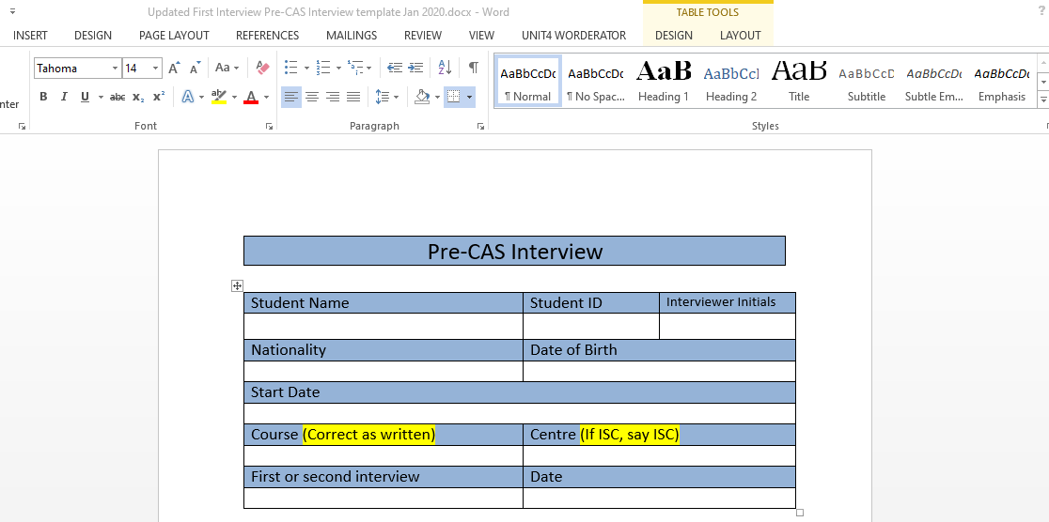

Aside from the interviewer initials, ‘First or second interview’ (i.e. is this the student’s first or second interview with Study Group) and date sections, you will need to access the student’s profile on the [Student Search function](https://sg.studygroup.com/StudentManagement/Student/StudentSearch.aspx) on the Study Global website to find the rest of the details. Study Global is the online database used to store information about each student and their application, as well as key documents associated with their application. You can access Study Global and the search function via the hyperlink above, or via the [myStudyGroup homepage](https://my.studygroup.com/Pages/Home.aspx).

The search function is shown in the image below. When you need a student’s personal/course details before an interview, you can use the search box located in the top-right hand corner to search for the student’s profile by entering their unique Student ID, Booking ID (i.e. Appointment ID) or Agent URN. The easiest method is to copy and paste the student’s Student ID from their profile page on TimeTap (see Point 3 of the [TimeTap Guide](https://my.studygroup.com/teams/Visa%20Compliance%20UK%20and%20EU/_layouts/15/WopiFrame.aspx?sourcedoc=/teams/Visa%20Compliance%20UK%20and%20EU/Policy%20Library/Visa%20Team%20ONLY/8.%20Pre-CAS%20Interviews/5.%20TimeTap/TimeTap%20Guide.docx&action=default) for how to find this page). You can also search by other criteria such as name or date of birth.

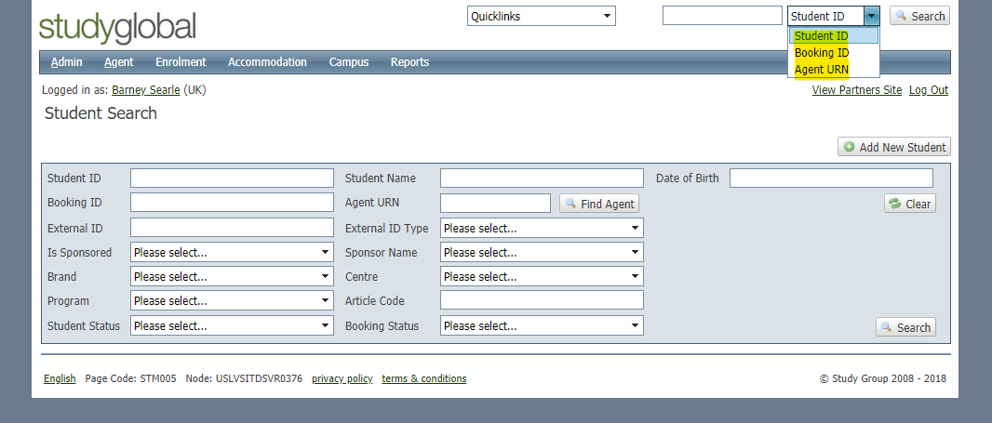

Once you have searched the student using the top-right hand search box, you will be re-directed straight to their Study Global profile (shown in the image below). This page shows their basic details, including name, Student ID, date of birth and nationality – these are located in the top section next to the student’s picture. The student’s name and Student ID can be found here:

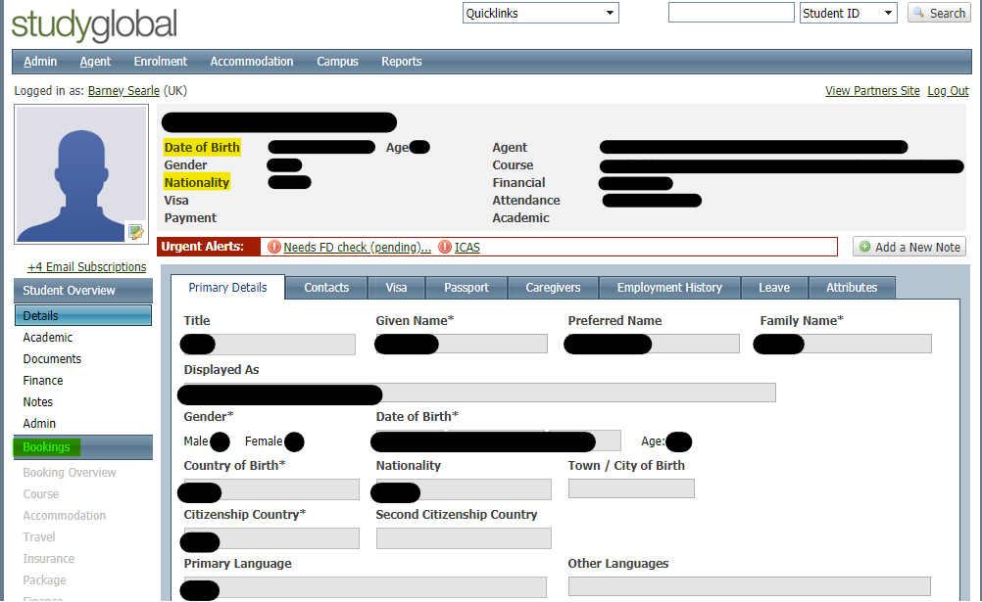

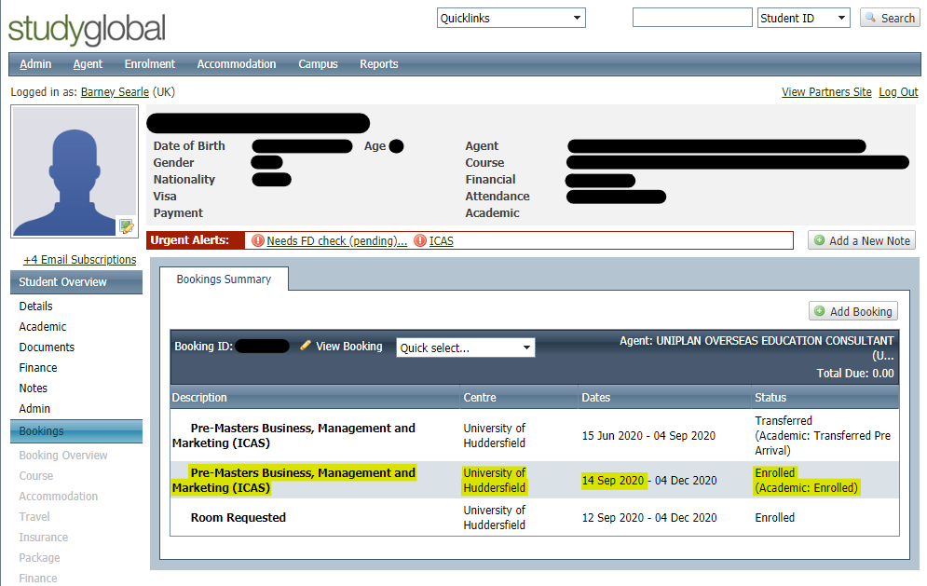To find the details of the student’s course, go to ‘Bookings’ on the left-hand side of the page (highlighted in green above) – this will re-direct you to the page shown below. This will show you the student’s course, the centre they are applying for, the start date of their course, and the status of their application (highlighted in yellow below).

As well as adding this information to the interview template, you should also check the following:

* The start date of the course should be after the current date. If the start date has already passed, you will need to ask the student in the interview why they have applied late (there is a question for this on the template). The interview can still go ahead if after the course start date, apart from specific cases where the university has decided to not accept applications past a certain date (you will be informed when this is the case).
* The status of the student’s application needs to be ‘Enrolled’ for them to be interviewed. If the status is anything else (e.g. ‘Place Offered’), you should contact the Visa Compliance Manager to check if the interview can go ahead or if it needs to be cancelled.

You should also search the course online, and open the website page for this course and university to familiarise yourself with these, therefore gaining a sense of what answers the student should give for questions such as course details and university location/facilities. For example, this link to [the homepage for the University of Huddersfield’s pathway programmes for international students](https://www.huddersfieldisc.com/) shows some of the information that will be useful to research beforehand e.g. ‘why study in the UK’, ‘Why Huddersfield?’, and information about the different courses offered at the University.

Once you have added these details to the interview template and all of the sections have been filled, you should then save your own copy of the interview template in you documents, with the student’s name and Student ID as the title of the document.

You can either prepare interview templates for all of your scheduled appointments at the beginning of the day, or prepare a template for each student before each interview takes place.

## Contacting the student

When it is time to conduct the interview, you should use the contact details found on the student’s profile page on TimeTap (see image below) to contact them.

It is preferred that the interviews are conducted via Skype – this is so you can see the student during the interview and ensure they are not using notes or receiving assistance at any point. However, if you are having issues with Skype or you cannot understand the student over Skype due to a poor network quality, you can call the student using the phone number provided on their profile to conduct the interview. However this should only be used if the interview cannot be completed over Skype.

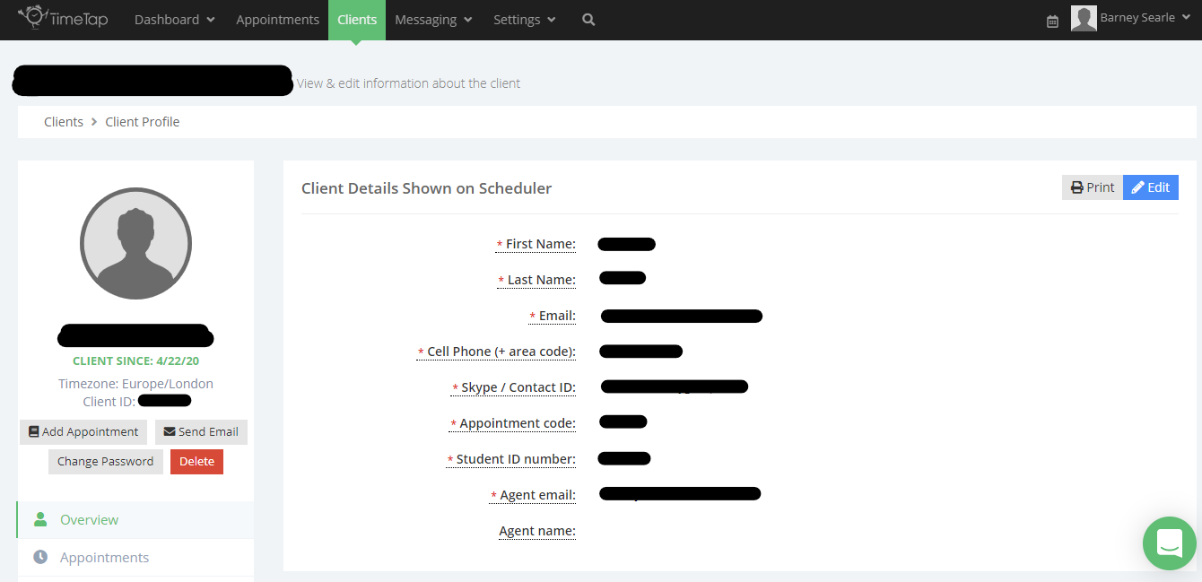

To contact the student via Skype, you firstly need to add their Skype details onto your Skype for Business Account. To do this, copy their Skype name from their TimeTap profile into the ‘Find someone new or dial a number’ box on Skype for Business. The student’s account should then come up – right click on the student, go to ‘Add to Contact List’ and then select the contact group you would like to add the student to. This will send the student a contact request, so that they can see you are ready to conduct the interview. They can then accept your request, and you will be able to message and call the student on Skype.

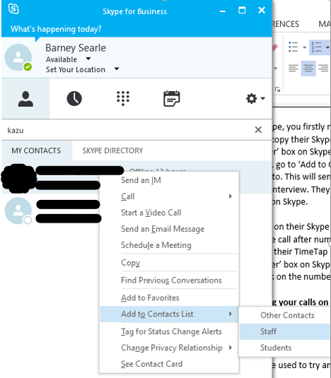

**To call the student**, right-click on their Skype name, go to ‘Call’ and select ‘Skype for Business Call’. If they do not answer your Skype call after numerous attempts, try to contact them via their phone number provided for them on their TimeTap profile – copy and paste their phone number into the ‘Find someone or dial a number’ box on Skype for Business, right-click the phone number result that comes up, go to ‘Call’ and click on the number.

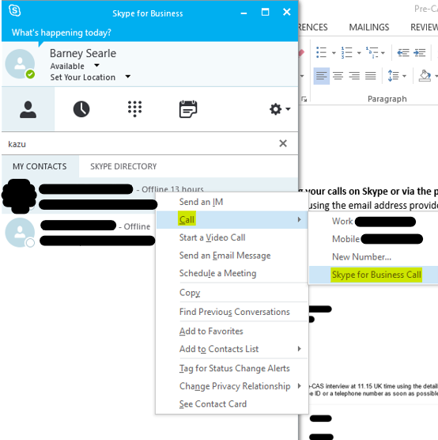

**If the student is not answering your calls on Skype or via the phone**, you should send the student and the student’s agent an email to remind them of their interview, using the email addresses for both (which can be found on the student’s TimeTap profile). The email should also copy in the student’s admissions coordinator, who will be assisting the student and agent through the application process.

You can find a student’s admissions coordinator on the student’s Study Global profile – on the student’s profile, firstly go to the ‘Bookings’ page and go to the drop-down list next to ‘View Booking’ in the student’s booking (see section highlighted in green in the image below). Make sure you do this on the correct booking i.e. the booking that says the student’s status is ‘enrolled’ - see section highlighted in yellow below).

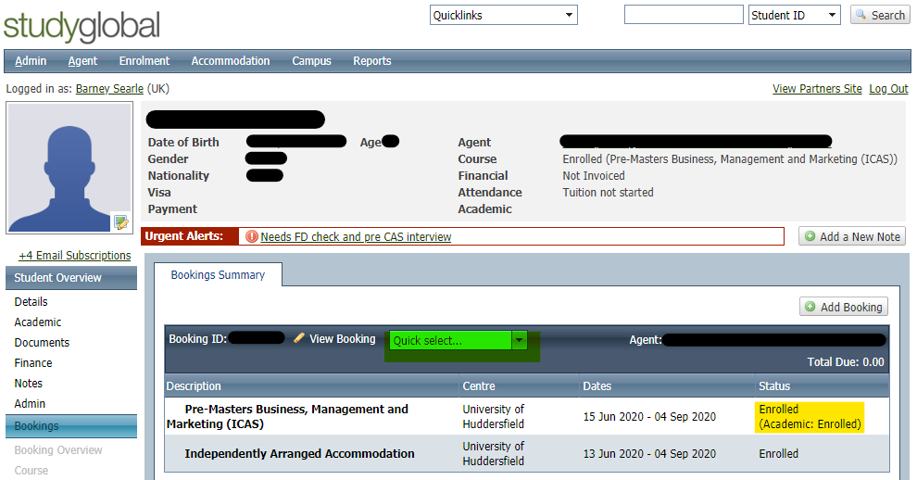

On the drop-down list, select ‘Admin’. This will then re-direct you to the page shown below – the name of the student’s admissions coordinator can be found next to ‘IAC’.

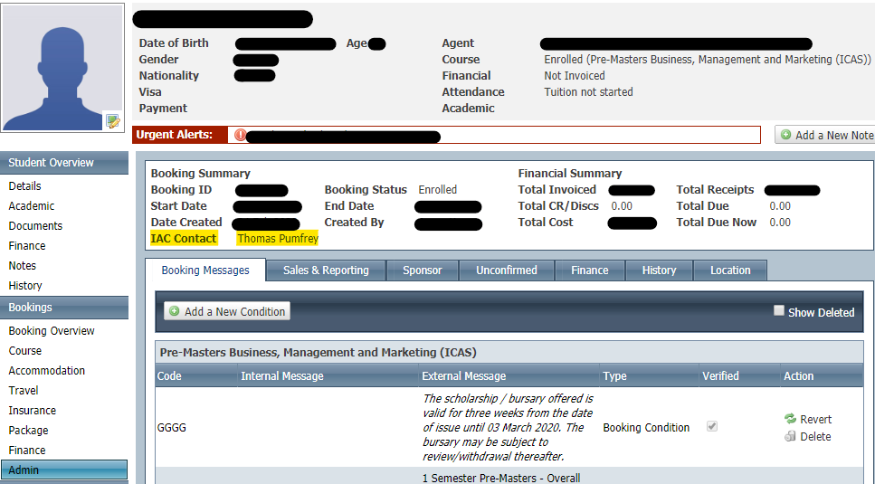

The email to remind the student of their interview should ask the student to provide their contact details so you can contact them. You can use ‘Snip & Sketch’ to take a screenshot of the student’s TimeTap profile, and copy and paste this into the email to show the student which details you have used to try and reach them. Below is an example of this email.

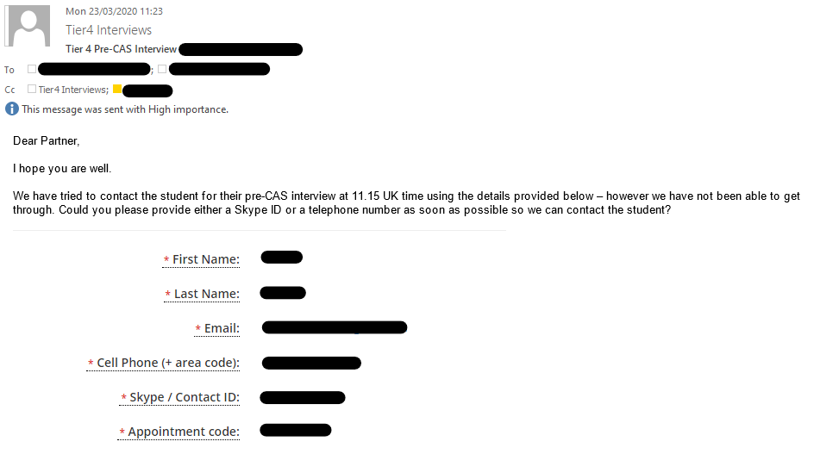To copy in the email address of the admissions coordinator, click on ‘Cc…’ to bring up the box shown in the image below. Search for and click on the admissions coordinator’s name, then select ‘Cc ->’ in the bottom-left corner to add them to the ‘Cc…’ row in the email – then press ‘OK’ in the bottom-right hand corner of the box.

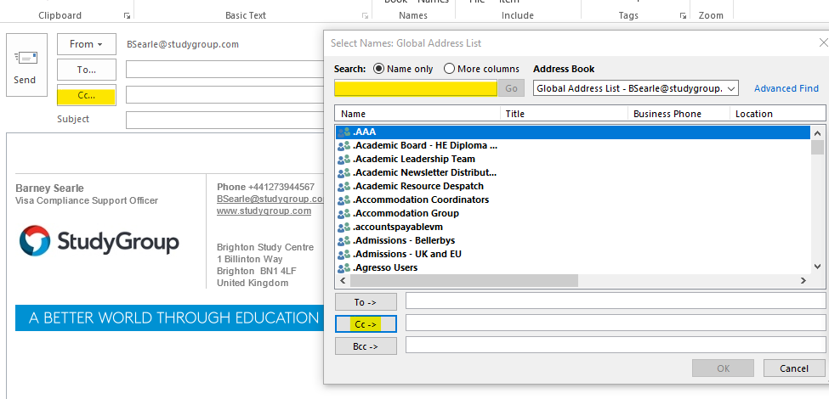

You should continue trying to contact the student until there is around 20 minutes left before your next interview – after this point, there will not be enough time to conduct the interview without running past the start time of your next interview. At that point, you will need to cancel the interview on TimeTap (see point 9 on the [TimeTap Guide](https://my.studygroup.com/teams/Visa%20Compliance%20UK%20and%20EU/_layouts/15/WopiFrame.aspx?sourcedoc=/teams/Visa%20Compliance%20UK%20and%20EU/Policy%20Library/Visa%20Team%20ONLY/8.%20Pre-CAS%20Interviews/5.%20TimeTap/TimeTap%20Guide.docx&action=default)). When doing so, make sure to tick the boxes for notifying staff and the client. You should also email the student, their agent and their admissions coordinator to explain why the interview has been cancelled and ask them to re-book another interview slot on TimeTap.

## Post-interview

Once the interview is finished, you can review the interview and add your immediate thoughts to the ‘Notes and Concerns’ section at the end of the interview template.

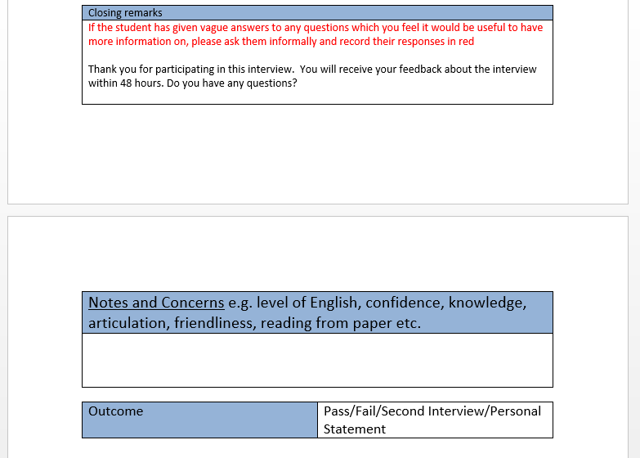

Once you have no more edits to make, the template needs to be uploaded to the student’s document page on Study Global. To do this, go to the student’s Study Global profile, and select the ‘Documents’ section on the left-hand side (highlighted in orange in the image below). This will bring up a list of all the documents uploaded in support of the student’s application and the date they were uploaded.

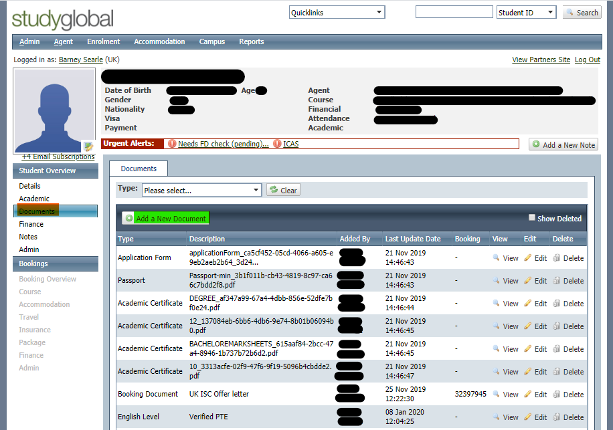

To add the student’s interview transcript to the documents page, select ‘Add a New Document’ (highlighted in green above). This will bring up the box shown in the image below.

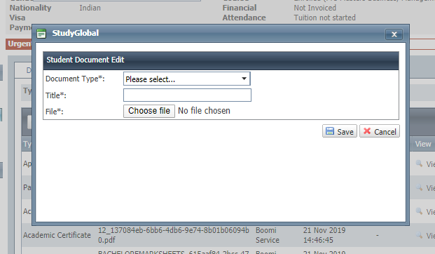

For Document Type, select ‘Visa / Immigration’. Write ‘Pre-CAS Interview Transcript’ for title, and then upload the student’s interview transcript that you saved in your documents. Then select ‘Save’ – the document will then be added to the student’s list of documents, and you will be able to see the document and the date it was uploaded at the bottom of the document list.

## Emailing the student

You then need to email the student following the interview, copying in the agent and admissions coordinator. The [‘Interview Feedback Links’](https://my.studygroup.com/teams/Visa%20Compliance%20UK%20and%20EU/_layouts/15/WopiFrame.aspx?sourcedoc=/teams/Visa%20Compliance%20UK%20and%20EU/Policy%20Library/Visa%20Team%20ONLY/8.%20Pre-CAS%20Interviews/2.%20Feedback%20Templates/Combined%20Interview%20Feedback%20-%2031.05.2018.docx&action=default) document contains example email structures for when you have ‘passed’ a student and for when you are asking a student to book a second interview.

The email you need to send is dependent on the outcome of the interview:

* If you are satisfied with the interview, you can pass the student and provide feedback for what they could improve, using the [Interview Feedback Links](https://my.studygroup.com/teams/Visa%20Compliance%20UK%20and%20EU/_layouts/15/WopiFrame.aspx?sourcedoc=/teams/Visa%20Compliance%20UK%20and%20EU/Policy%20Library/Visa%20Team%20ONLY/8.%20Pre-CAS%20Interviews/2.%20Feedback%20Templates/Combined%20Interview%20Feedback%20-%2031.05.2018.docx&action=default) document.
* If you are not satisfied with the interview, you can either:
  + Ask the student for a personal statement that provides further detail on sections of the interview that you feel further clarity is needed on, or;
  + Ask the student to book a second interview, and outline areas for the student to improve on using the [feedback links](https://my.studygroup.com/teams/Visa%20Compliance%20UK%20and%20EU/_layouts/15/WopiFrame.aspx?sourcedoc=/teams/Visa%20Compliance%20UK%20and%20EU/Policy%20Library/Visa%20Team%20ONLY/8.%20Pre-CAS%20Interviews/2.%20Feedback%20Templates/Combined%20Interview%20Feedback%20-%2031.05.2018.docx&action=default) document.

If the student takes a second interview, or provides a personal statement, you can pass the student if you think the student has demonstrated enough improvement in these. However, if you still have concerns or you are unsure, then you can refer the case to the Visa Compliance Manager to make a final decision on the case.

When you are referring/escalating a case to the Visa Compliance Manager (e.g. if a red flag appears in a student’s interview, or if you want to refer a personal statement), you should follow the process below:

* Make sure Tier 4 Interviews are copied into the email – this will help keep a record of the student’s application status for all Visa Compliance staff to see.
* Attach to the email the student’s interview transcript and any documents/personal statement that the student has provided since the interview.
* In the email itself, firstly outline that you have conducted an interview for the student, and outline the course and university the student is applying for. If you asked for further information from the student following the interview, then state what details you asked. Then outline the concerns that you have regarding the case, highlight any attached documents and ask how the Visa Compliance Manager would like to proceed with the case.
* If the Visa Compliance Manager is unavailable, they will have allocated another member of staff for you to email for case referrals – use the same process for emailing this member of staff regarding your referral.

The process for referrals changes slightly for ICAS cases – these are cases that need to be referred to the University themselves to adjudicate on any concerns, rather than just to the Visa Compliance Manager.

If you are escalating an ICAS case, then the Visa Compliance Manager may refer this to the University for a final decision on the case. If the case is an ICAS, you should use the following email template for passing the case onto the Visa Compliance Manager, so that this can then be easily passed on to the University:

**When passing on an ICAS case where there has been a previous Visa Refusal**

*Dear XXX*

*Following our pre-CAS interview with the below student, we asked for a copy of their visa refusal letter from their previous visa refusal, as well as the reasons for their refusal.*

*Name: XXX*

*Age: XXX*  
*Nationality: XXX*

*Course: XXX*

*The reason for the student’s previous refusal was [insert reason for refusal in detail]. [Insert whether we still have the same concern with their pre-CAS interview as that which led to their previous visa refusal].*

*The student’s interview transcript and their visa refusal letter are both attached above. Please let me know how you would like us to proceed with this case.*

*Kind regards,*

*XXX*

**When passing on an ICAS case with which you have more general concerns**

*Dear XXX,*

*We have conducted a preparatory credibility interview with the below student and have some concerns, so we are referring this case to you.*

*Name: XXX*

*Age: XXX*  
*Nationality: XXX*

*Course: XXX*

*We asked the student to provide a personal statement covering our concerns, which are outlined below:*

* *XXX*
* *XXX*
* *Etc.*

*The student’s personal statement and interview transcript are attached. Please let me know how you would like us to proceed with this case.*

*Kind regards,*

*XXX*

Once the university have made a decision, they will then notify the Visa Compliance Manager, who will then inform you of their decision. You then need to relay this decision to the student, their agent and their admissions coordinator.

You can only fail the student if this decision has been approved by the Visa Compliance Manager – **you must receive approval from the Visa Compliance Manager before you give a student a ‘fail’**.

The [Pre-CAS Interview Red Flag List](https://my.studygroup.com/teams/Visa%20Compliance%20UK%20and%20EU/_layouts/15/WopiFrame.aspx?sourcedoc=/teams/Visa%20Compliance%20UK%20and%20EU/Policy%20Library/Visa%20Team%20ONLY/8.%20Pre-CAS%20Interviews/4.%20Training%20materials/Pre-CAS%20Interview%20Red%20Flag%20list%20(Internal%20only).pdf.docx&action=default) document provides a guide for how to decide whether an interview should be passed, failed, or whether a personal statement or second interview are necessary.

After sending these emails, you should check your emails regularly for replies from agents or students (especially if they are providing further information you have asked for).

## Update Interview Outcomes spreadsheet

Points 2-6 should be completed for each appointment you have booked.

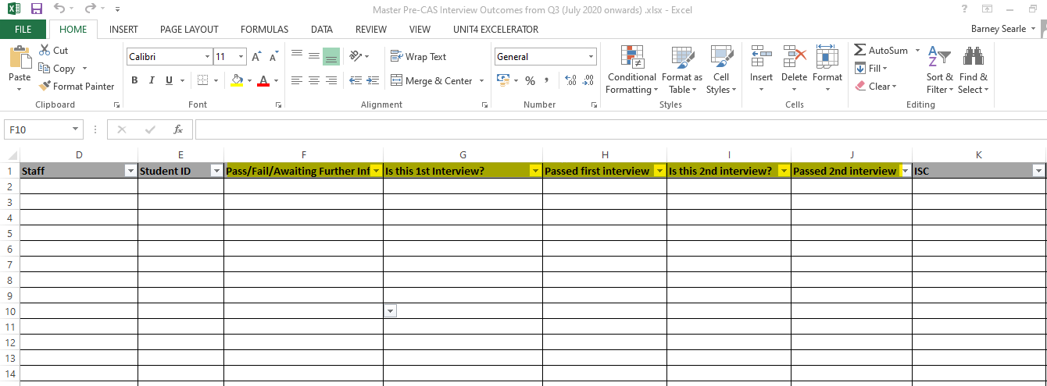At the end of each day, once all appointments have been completed and emails have been sent to students and their agents, you should update the [Interview Outcomes spreadsheet](https://my.studygroup.com/teams/Visa%20Compliance%20UK%20and%20EU/_layouts/15/WopiFrame.aspx?sourcedoc=/teams/Visa%20Compliance%20UK%20and%20EU/Policy%20Library/Visa%20Team%20ONLY/8.%20Pre-CAS%20Interviews/Master%20Pre-CAS%20Interview%20Outcomes%20from%20Q3%20(July%202020%20onwards)%20.xlsx&action=default) by entering the results of the day’s interviews into the corresponding column of the spreadsheet (which column depends on whether the interview is a 1st or 2nd interview – see the image below).

For example, if the interview you have conducted is a first interview, then you should fill in columns G and H (see the image above), and put ‘N/A’ for columns I and J. For second interviews, the cells for columns G and H should be marked ‘N’ (as this is not their first interview).

On the spreadsheet, you should also update the interview outcome for any students who have been interviewed on a previous day, but whose interview status has now changed (e.g. they have provided a personal statement and have now been referred to the Visa Compliance Manager or passed).

If you have requested further information from a student, it is your responsibility to ensure that the student’s row on the spreadsheet is kept updated. You should chase students for further information once 2 working days have passed since you requested the information.